Ideation Phase
Empathize & Discover
Date | 3 October 2026
Team ID | SWTID-2026-9505
Project Name | Implement Client Script & UI Policy (Incident) - ServiceNow
Maximum Marks | 4 Marks
Empathy Map Canvas:
An empathy map is a simple, easy-to-digest visual that captures knowledge about a user's behaviours and attitudes.
It is a useful tool to helps teams better understand their users. Creating an effective solution requires understanding the true problem and the person who is experiencing it. The exercise of creating the map helps participants consider things from the user's perspective along with his or her goals and challenges.
Example:
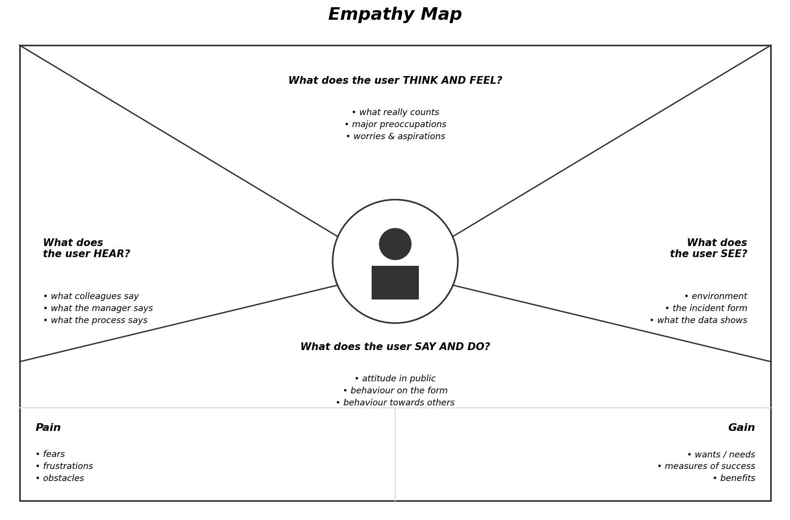
Reference: https://www.mural.co/templates/empathy-map-canvas

Example: Incident Form Management in ServiceNow (UI Policy & Client Scripts)
